Project 3-1 Using OpenPuff Steganography

- Use your web browser to go to embeddedsw.net/OpenPuff_Steganography_Home.html.
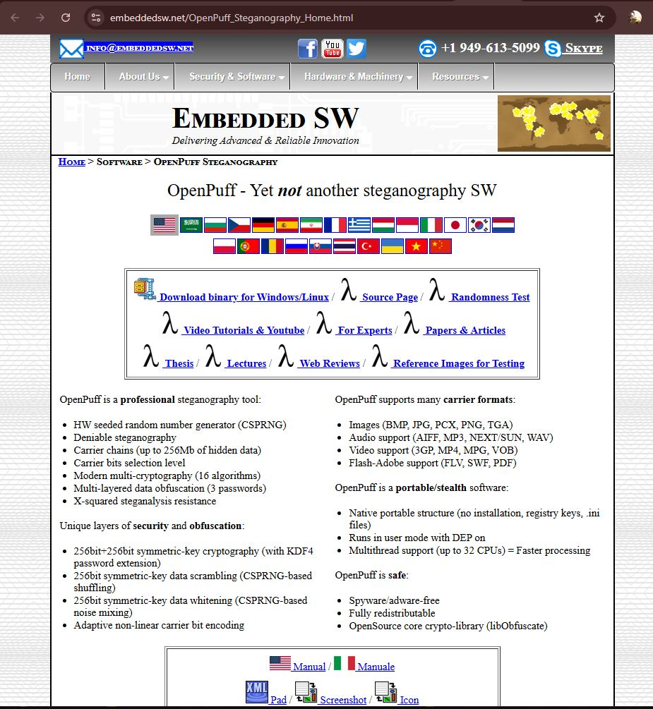
- Click Manual to open the OpenPuff manual. Save this file to your computer. Read through the manual to see the different features available.
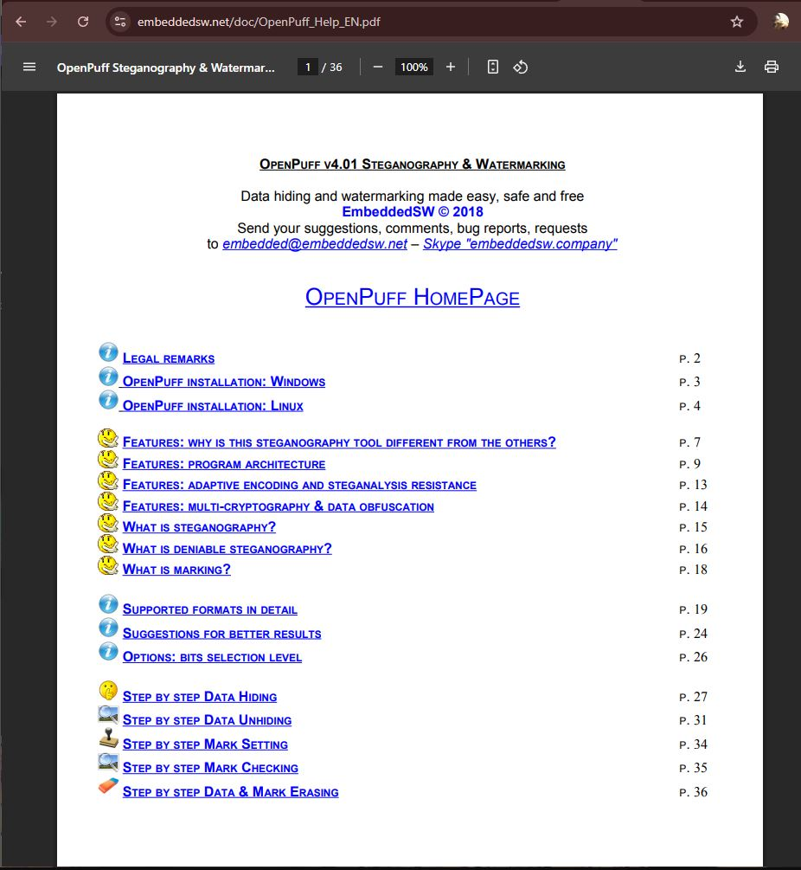
- Click OpenPuff to download the program.
- Click Screenshot to view a screen capture of OpenPuff. Right-click on this image and save this image OpenPuff_Screenshot.jpg to your computer. This will be the carrier file that will contain the secret message.
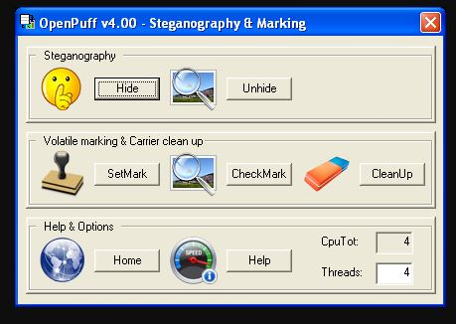
- Navigate to the location of the download and uncompress the Zip file on your computer.
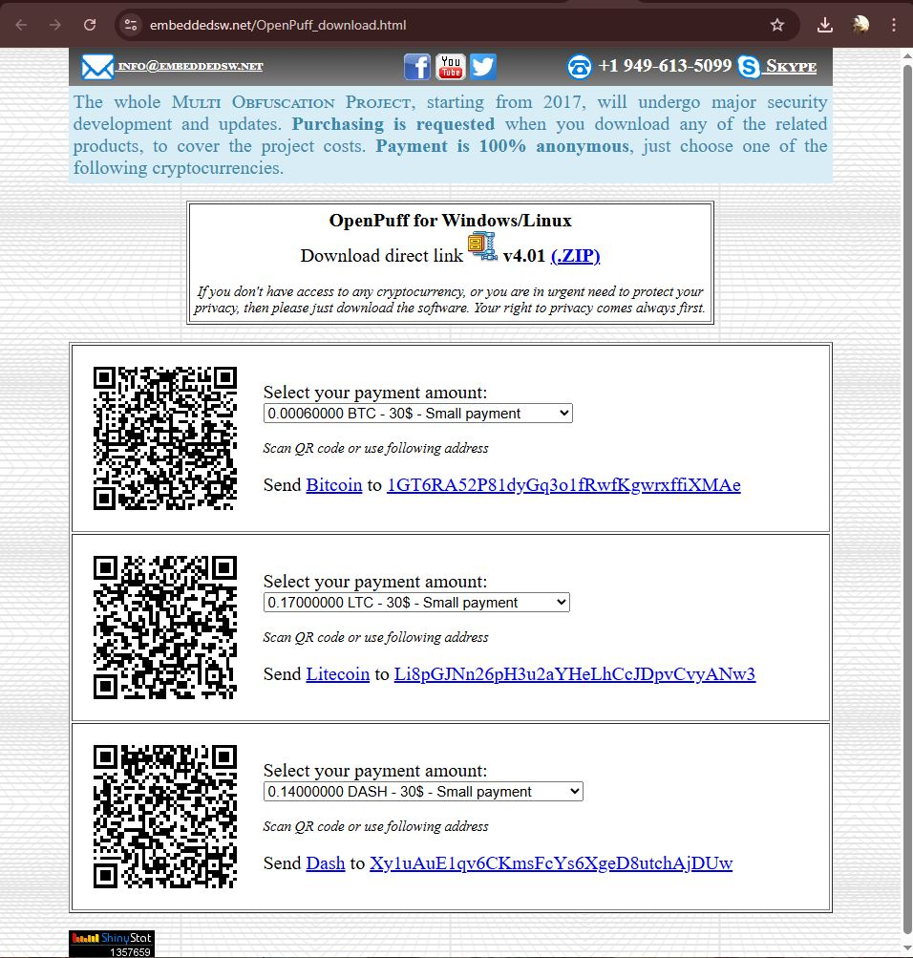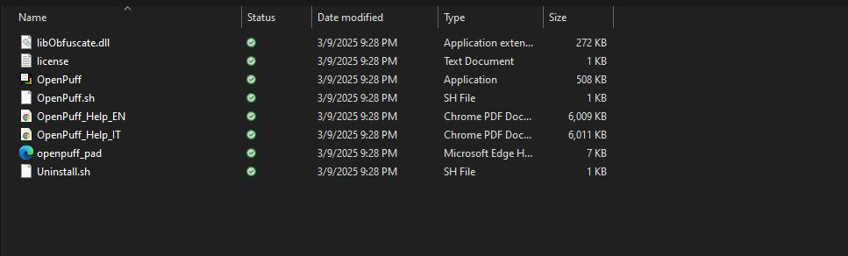
- Now create the secret message to be hidden. Open Notepad and enter “This is a secret message”.
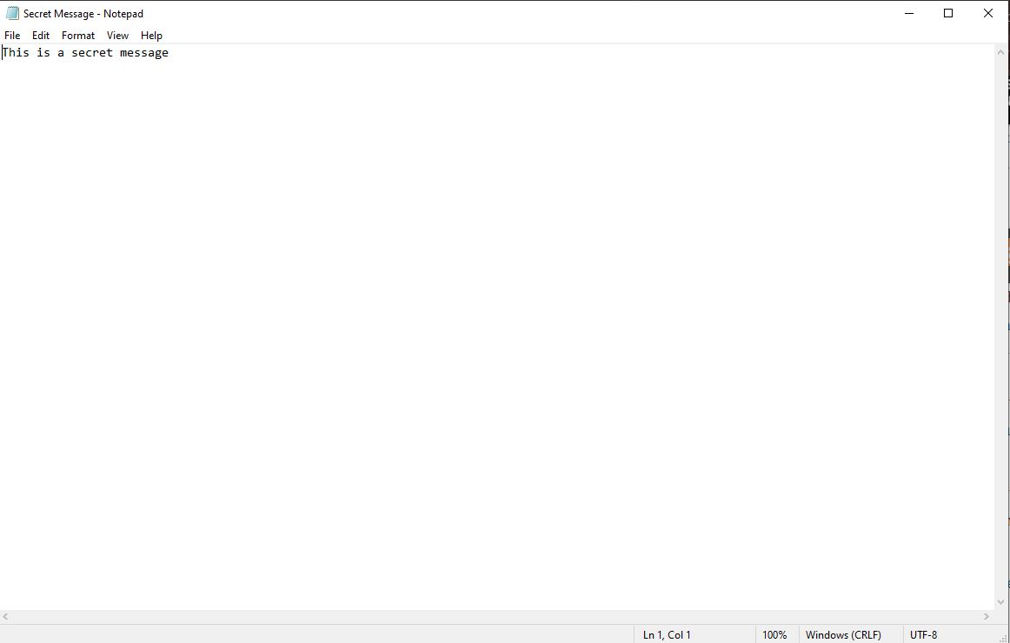
- Save this file as Message.txt and close Notepad.
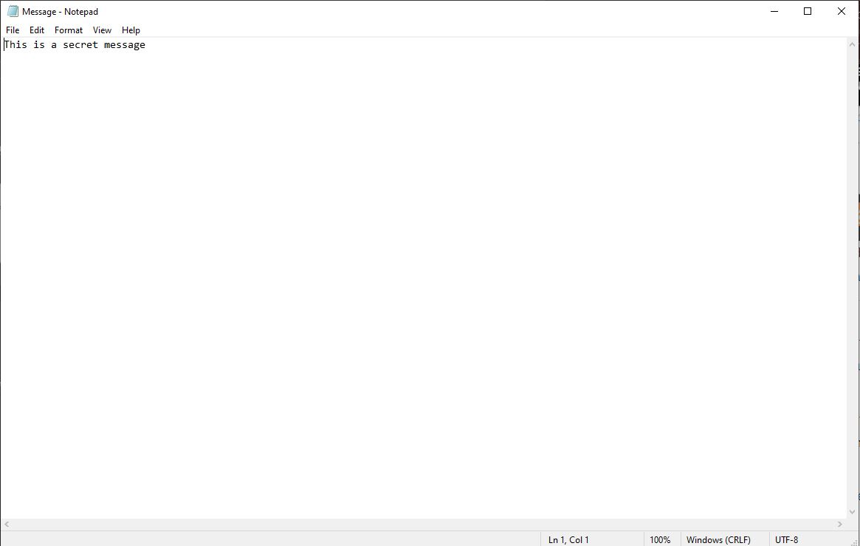
- Create a Zip file from the Message file. Navigate to the location of this file through Windows Explorer and click the right mouse button.
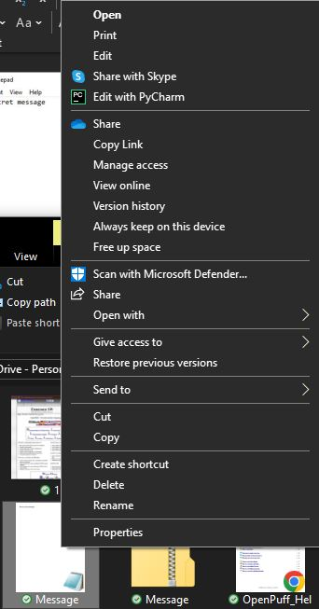
- Click Send to and select Compressed (zipped) folder to create the Zip file.
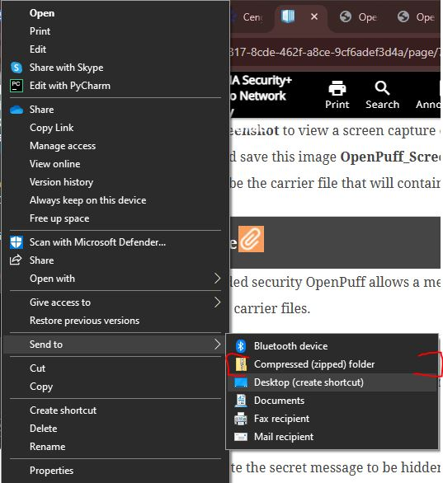
- Navigate to the OpenPuff directory and double-click OpenPuff.exe.
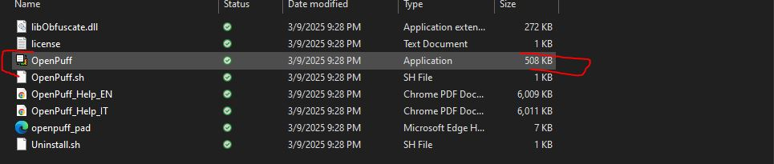
- Click Hide.
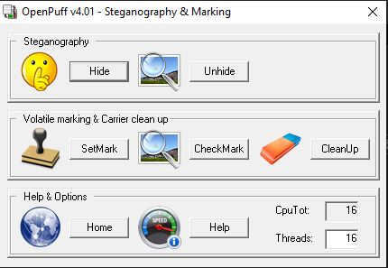
- Under (1) create three unrelated passwords and enter them into Cryptography (A), (B), and (C). Be sure that the Scrambling (C) password is long enough to turn the Password check bar from red to green.
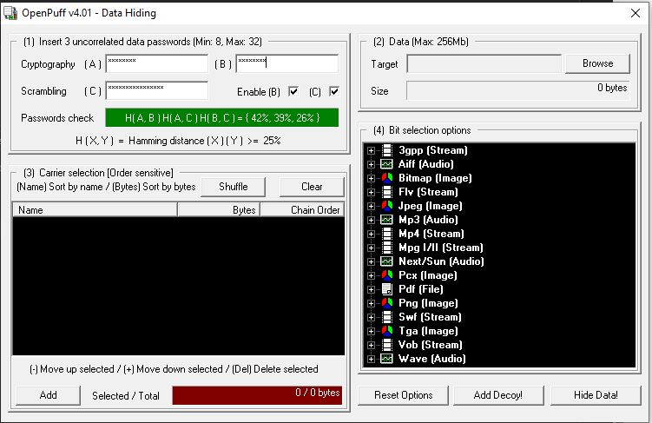
- Under (2) locate the message to be hidden. Click Browse and navigate to the file Message.zip. Click Open.
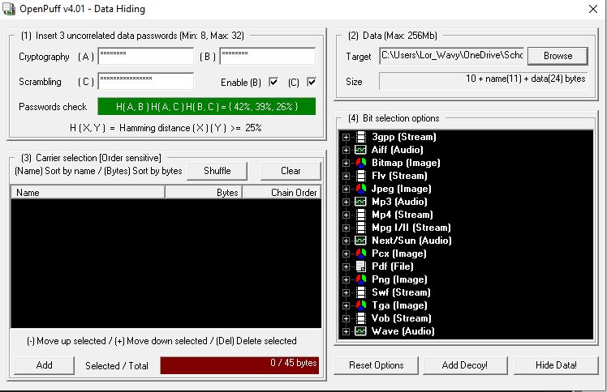
- Under (3) select the carrier file. Click Add and navigate to OpenPuff_Screenshot.jpg as shown in Figure 3-11.
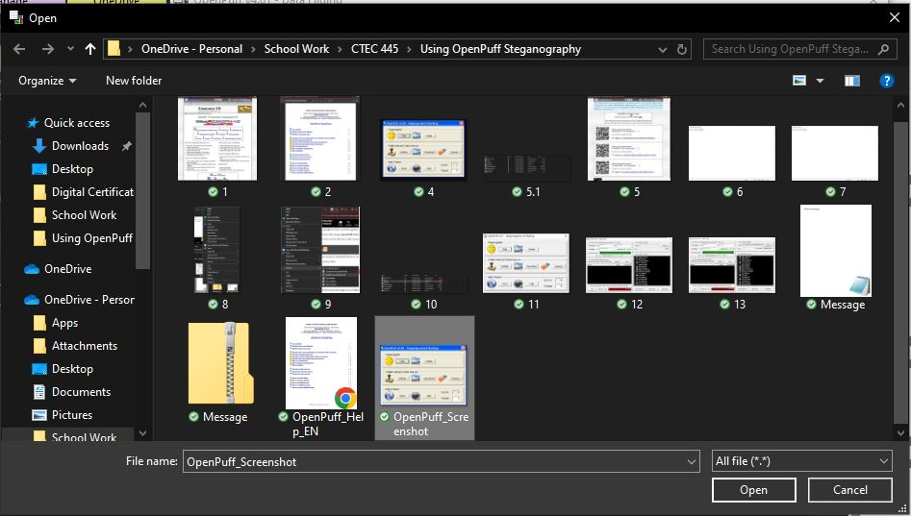
- Click Hide Data!
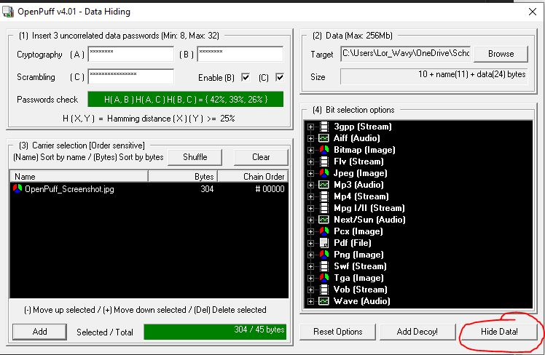
- Navigate to a different location than that of the carrier files and click OK.
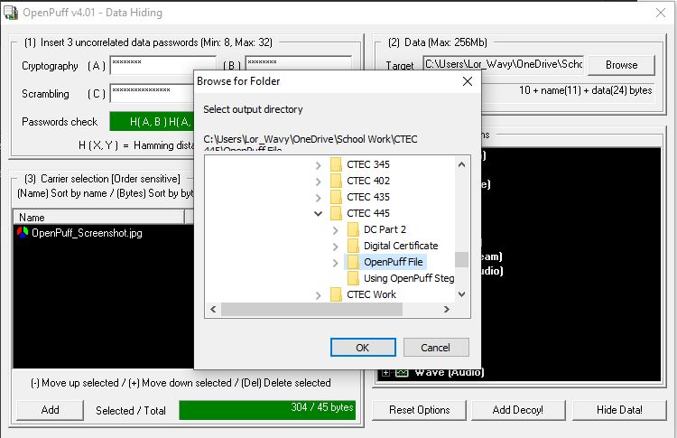
- After the processing has completed, navigate to the location of the carrier file that contains the message and open the file. Can you detect anything different with the file now that it contains the message?
Answer: I could not spot a difference between the two images
- Now uncover the message. Close the OpenPuff Data Hiding screen to return to the main menu.
- Click Unhide.
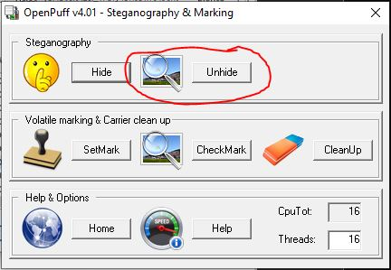
- Enter the three passwords.
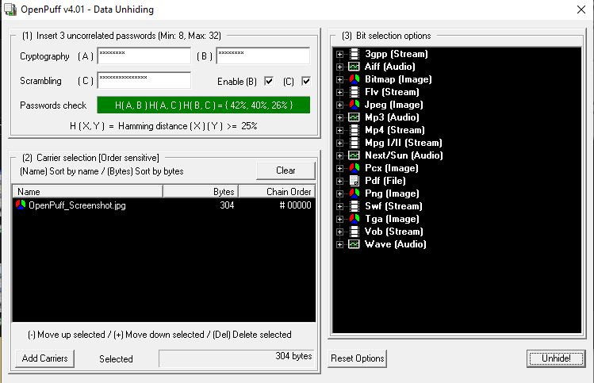
Forgot the Scrambling Password
- Click Add Carriers and navigate to the location of Carrier1 that contains the hidden message.
- Click Unhide! and navigate to a location to deposit the hidden message. When it has finished processing click OK.
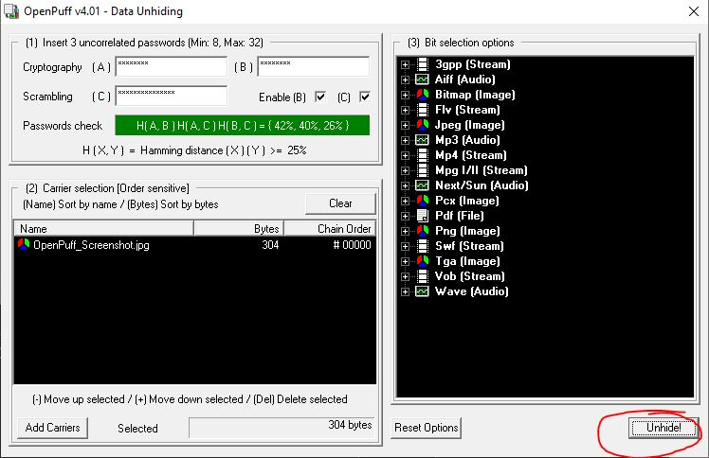
- Click Done after reading the report.
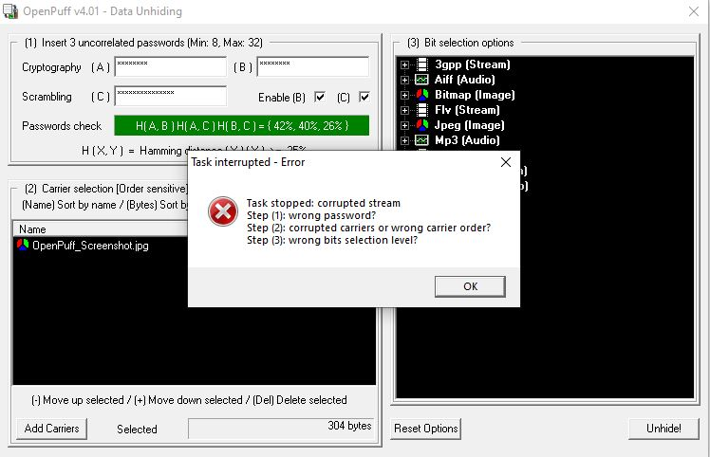
- Go to that location and you will see Message.zip.
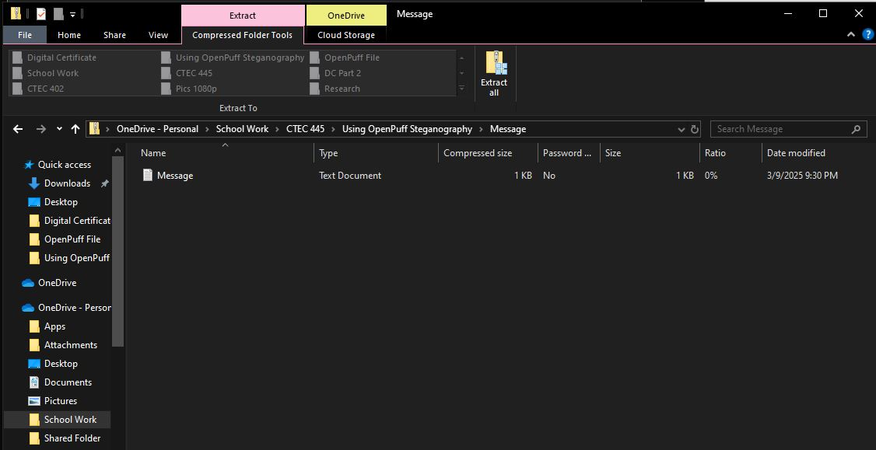
- Close OpenPuff and close all windows.
The project in general was fine, but I did encounter some problems but mainly user errors. When hiding the message, I did not spot any differences and I even asked ChatGPT to see if it seen anything but visual it did not see anything differently. Then the other issue I ran into was me forgetting the password that I used to do the Part C scrambling password. So, I could not finish the very last part due to that.

